一.

1. a
2. a
3. b
4. b
5. b 送分
6. b,c,d 擇一
7. b
8. e
9. b
10. d
11. b
12. e
13. c
14. b
15. d
16. b
17. a

二

1.(有問題)

a.

400=>因為foo.o size是300 所以Y上去就會在400的位置

4000=>其他prjecto佔據，所以從4000 開始

4100=>4000加上X的記憶體位置

4400=>加上foo.o的 size (到4300)再加上Y的記憶體位置，所以是4400

b.

開傳案 選專案 寫 hello world (寫步驟)

2.

a.

Loop result are -1,1

Loop result are -2,0

Loop result are -4,-2

Loop result are -8,-6

Loop result are -16,-14 無窮迴圈

b.

int i =1,k = 0;

while (i < 10 && k < 4)

{

k+= i; i= k-2;

Console.WriteLine( "\n loop result are {0}, {1}", i, k );

i++;

k--;

}

int i =1, k = 0;

do

{

k+= i; i= k-2;

Console.WriteLine( "\n loop result are {0}, {1}", i, k );

i++;

k--;

} while (i < 10 && k < 4);

3.

a.128位元的浮點數資料型態，10進位，

b.求某個數的次方數，例如：2^10=>math.pow(2,10) class name static methon

c.\t=>空格(tab) , 字串輸出格式 EX: $20 的 $ 字號

4.

Stap 1 PC=300.

Stap 2 IR=1940

Stap 3 IR=5941

Stap 4 AC=0005

Stap 5 IR=2941

Stap 2 IR=2941

5.

Figure 5.a

after line 8, main count =0;

after line 9, main count =20;

after line 14, add_C count =10

after line 15, add_C count =11,

after line 14, add_C count =10,

after line 15, add_C count =11

Figure 5.b

after line 18,main count =30;

after line 20,main count =20;

after line 25, main count =31;

after line 27, sub.c count =8

after line 28, sub.c count =7

6.

a.

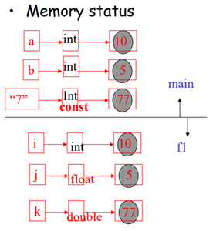

b.

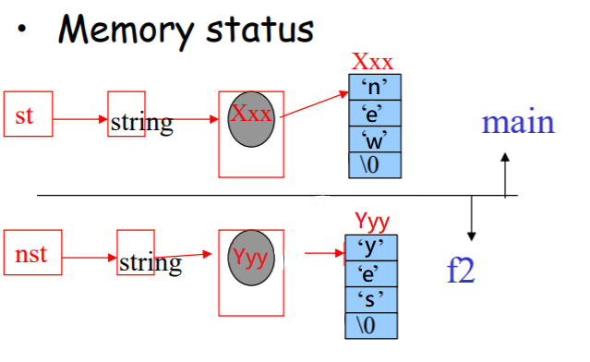

c.

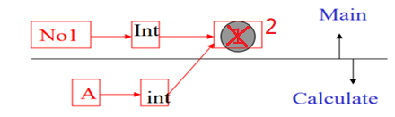

7.

a.

static void Main(string[] args)

{

int n = int.Parse(Console.ReadLine());

Console.WriteLine(pow(n));

}

static int pow(int n)

{

if (n > 1)

{ return (pow(n-1) *5); }

else

return 5;

}

b.

static void Main(string[] args)

{

int n = int.Parse(Console.ReadLine());

if(n>=-3)

Console.WriteLine(pow(n));

else

Console.WriteLine("數字要大於-3");

}

static int pow(int n)

{

if (n > -3)

{ return (pow(n-1)+n); }

else

return -3;

}

8.

• int b = 99;

b int 99

• int[] b = {14, 13, 15};

b int array xxx 0 14

1 13

2 15

• string s = “Good”;

s string yyy 0 ‘g’

1 ‘o’

2 ‘o’

3 ‘d’

4 ‘\0’

• int[][] b ={{11,12},{13,14,15}};

b int 2D array zzz 0 0 int array kkk 0 14

1 1 1 13

int array xxx 0 14

1 13

2 15

• string[] s = {“Yes”, “No”};

b string array zzz 0 0 string kkk 0 ‘Y’

1 1 1 ‘e’

2 ‘s’

3 ‘\0’

String xxx 0 ‘N’

1 ‘o’

2 ‘\0’

• String [] b1 = new String[ 2 ];

b1 string array zzz b1[0] ‘\0’

b1[1] ‘\0’

9.

|  |  |  |  |  |
| --- | --- | --- | --- | --- |
|  |  | Obj of Time2 |  |  |
|  |  | Hour=0 |  |  |
|  |  | Minute=0 |  |  |
|  |  | Second=0 |  |  |
|  |  | Obj of Time2 |  |  |
| TimeTest2 |  | Hour=2 |  | Time2 |
| time1 |  | Minute=0 |  | hour |
| Time2 |  | Second=0 |  | minute |
| Time3 |  | Obj of Time2 |  | second |
| Time4 |  | Hour=21 |  | Timer2() |
| Time5 |  | Minute=34 |  |  |
| Time6 |  | Second=0 |  |  |
|  |  | Obj of Time2 |  |  |
|  |  | Hour=12 |  |  |
|  |  | Minute=25 |  |  |
|  |  | Second=42 |  |  |
|  |  | Obj of Time2 |  |  |
|  |  | Hour=27 |  |  |
|  |  | Minute=74 |  |  |
|  |  | Second=99 |  |  |
|  |  | Obj of Time2 |  |  |
|  |  | Hour=12 |  |  |
|  |  | Minute=25 |  |  |
|  |  | Second=42 |  |  |

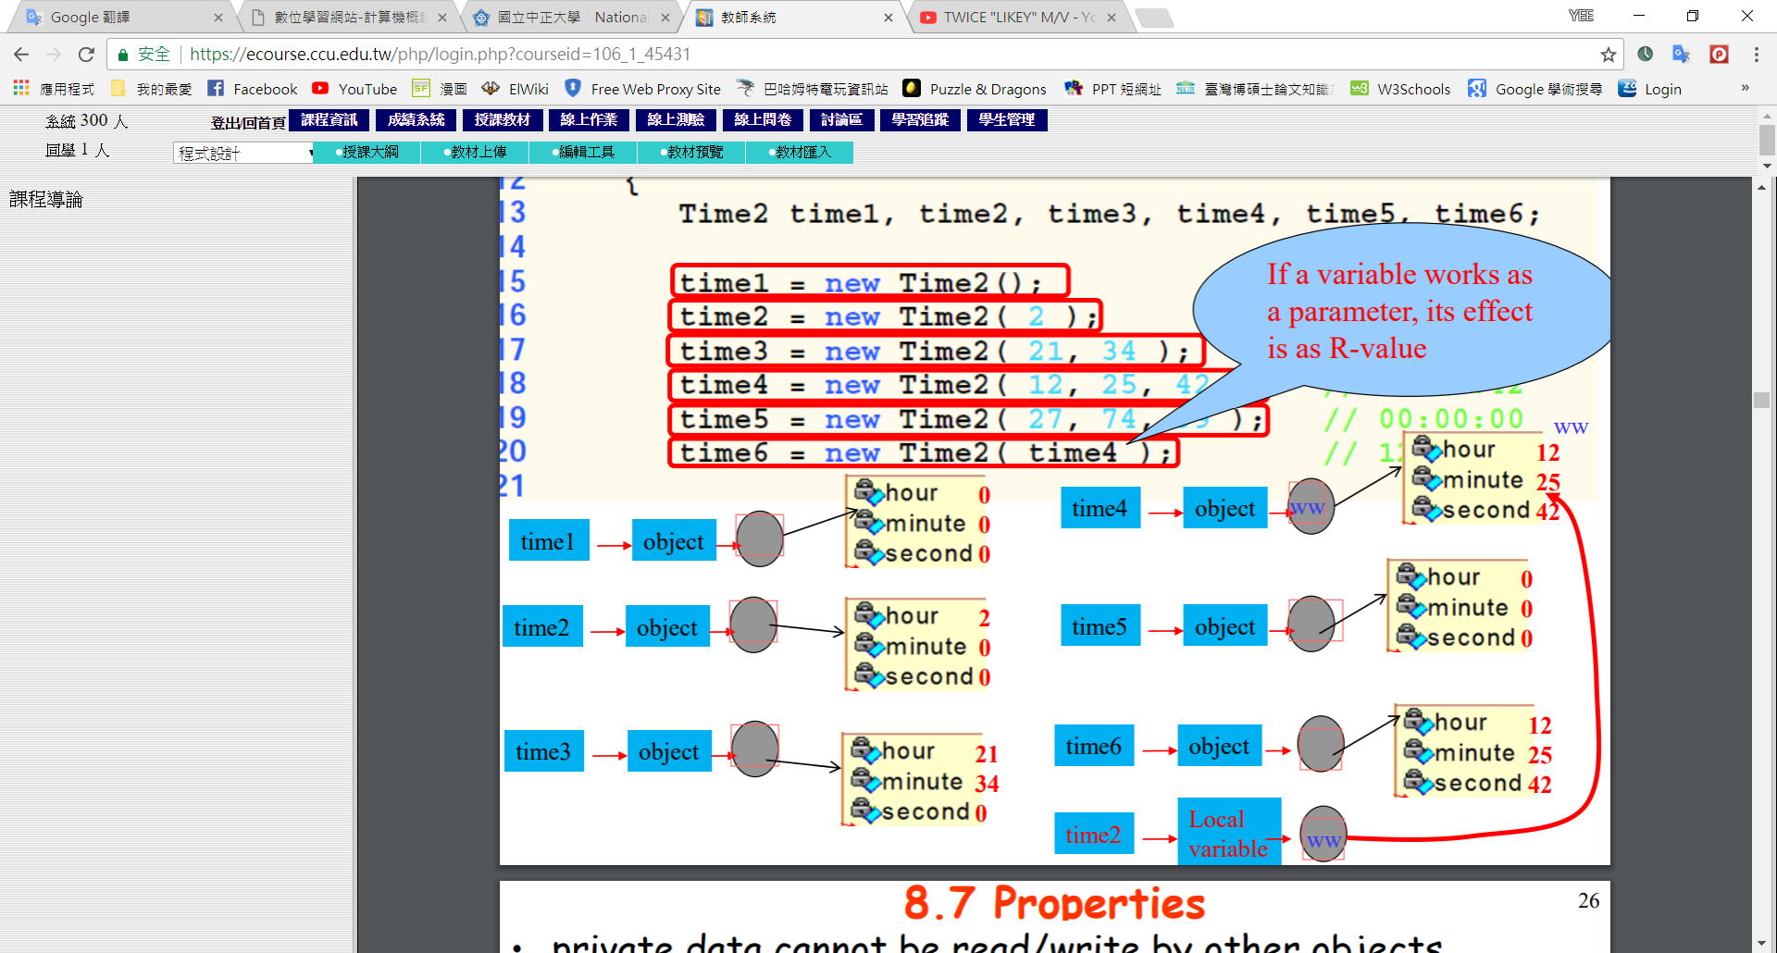

10.

a.

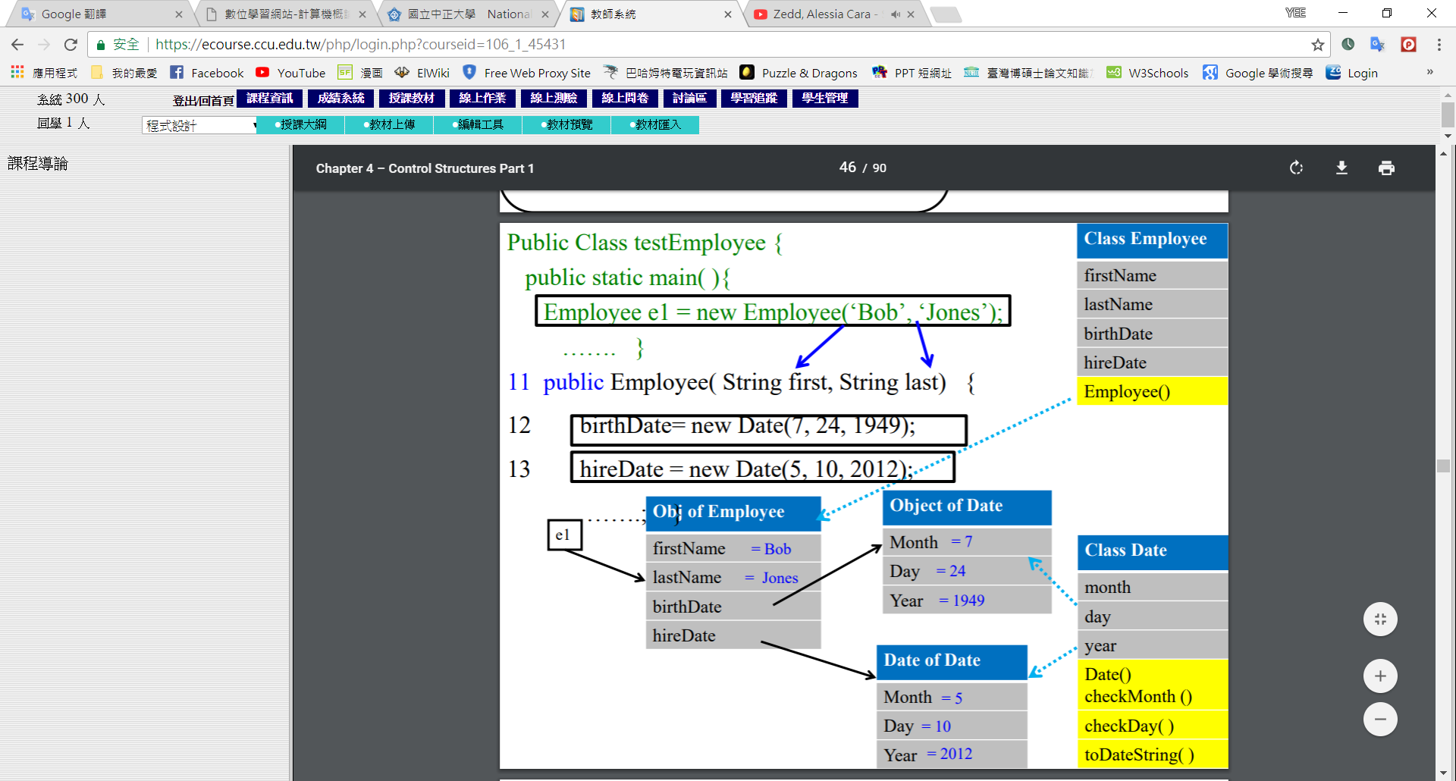

b.

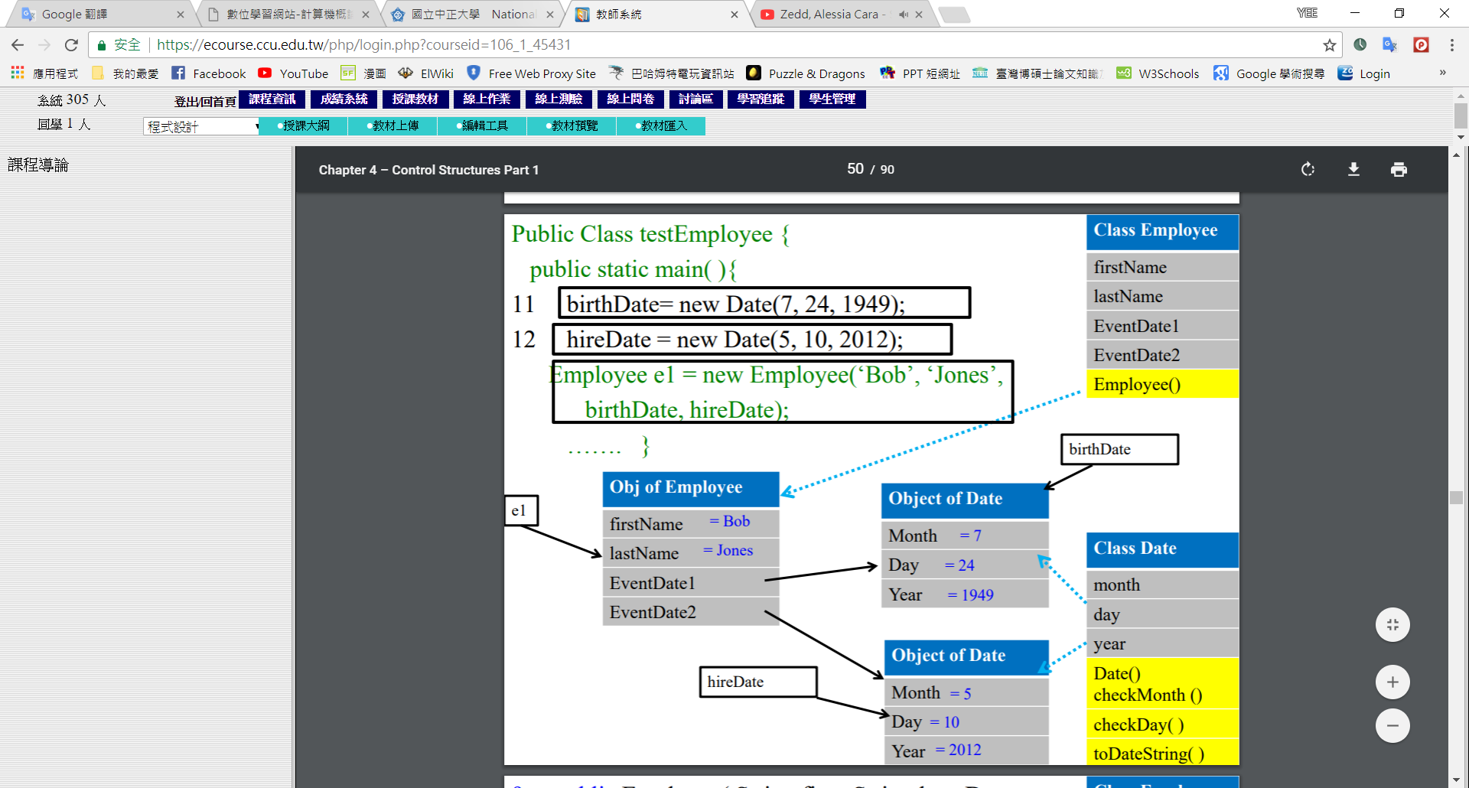

11.

